**PRODUCT STORE**

**Link**: https://www.demoblaze.com/index.html

**About:**

This website is about accessories of different types including following

* Phones
* Laptops
* Monitors

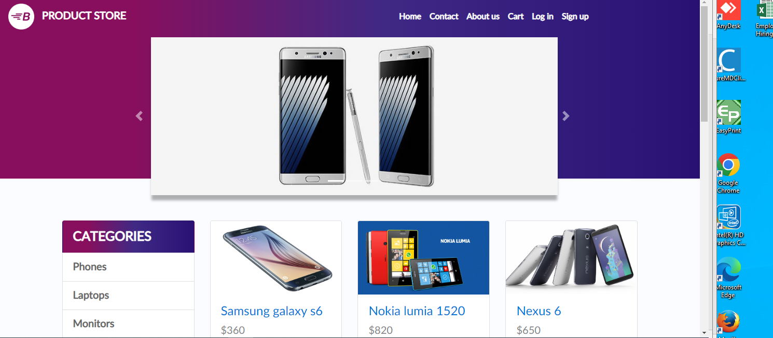

**BUGS**

**Bug Report ID: 01**

* Pre-requisites:
* Internet connectivity
* Web browser

**Summary**

When a product is open on smaller display navigation bar appearance affected.

**Expected Result:**

The navigation bar should open completely.

**Actual Result:**

It does not open completely.

**Issue:**

It is showing half of the screen.

Frequency: high

Severity: high

Priority: high

Assign to: Developer

**SCREENSHOT:**

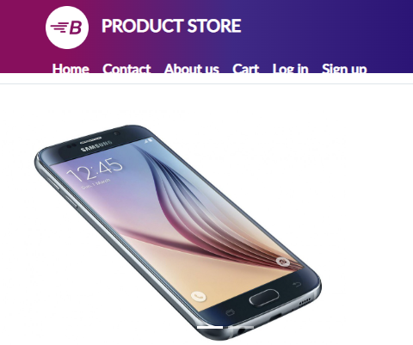

**Bug Report ID: 02**

**Pre-requisites:**

* Internet connectivity
* Web browser
* The Product store

**Actions Done:**

* Open **https://demo.vuestorefront.io**
* Press shop now
* Press clothes

**Expected Result:**

Show us clothes on the website

**Actual Result:**

Shows us kitchen items

**Issue:**

It is showing kitchen items instead of clothes

**Screenshot:**

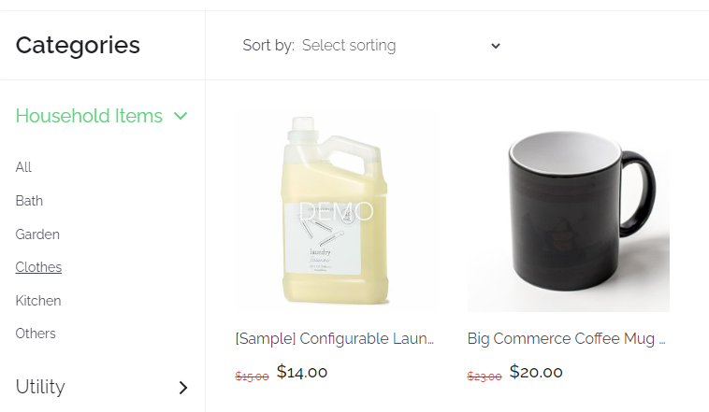

Frequency: high

Severity: high

Priority: high

Assign to: Developer

**Bug Report ID: 03**

**Pre-requisites:**

* Internet connectivity
* Web browser
* The web application should open

**Actions Done:**

* Go to demoblaze.com
* Click on cart
* Click on place order without adding any product
* Fill form
* Order is placed

**Expected Result:**

The error message with empty cart should be displayed.

**Actual Result:**

The order is placed.

**Screenshot:**

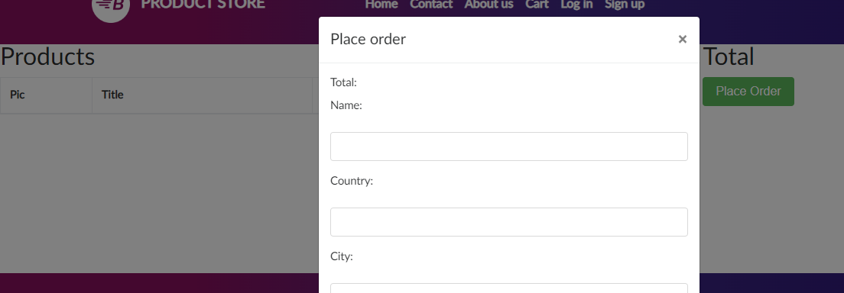

Frequency: high

Severity: high

Priority: high

Assign to: Developer

**Bug Report ID: 04**

**Pre-requisites:**

* Internet connectivity
* Web browser

**Actions Done:**

* Open **https://demo.vuestorefront.io**
* Press shop now
* Press bath

**Expected Result:**

Show us bath items available on the website

**Actual Result:**

Shows us coffee mug in bath item

**Issue:**

It is showing coffee mug instead of bath items

**Screenshot:**

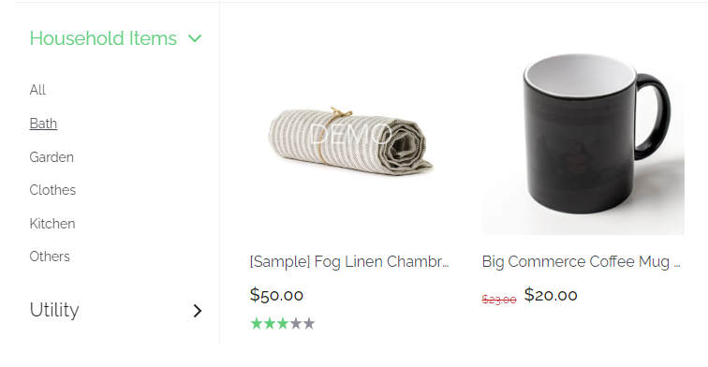

Frequency: high

Severity: high

Priority: high

Assign to: Developer

**Bug Report ID: 05**

**Pre-requisites:**

* Internet connectivity
* Web browser
* Product web should be open

**Summary**

When user successfully registers and place order, he is unable to visit profile page in order to track his order.

Link is static

**Actions Done:**

* Sign in to demoblaze.com
* Click on welcome

**Expected Result:**

Should show the profile page

**Actual Result:**

Do not show the profile page.

Frequency: high

Severity: high

Priority: high

Assign to: Developer

**Bug Report ID: 06**

**Pre-requisites:**

* Internet connectivity
* Web browser

**Actions Done:**

* Open **https://demo.vuestorefront.io**
* Press shop now
* Press utility
* Select item
* Add to cart
* Check out from cart
* Enter billing details
* Press place order

**Expected Result:**

Place order successfully

**Actual Result:**

Order not placed and error occurred

**Issue:**

Order not placing successfully

Frequency: high

Severity: high

Priority: high

Assign to: Developer

